**___________________________________________________________________________________________**

**The Creation of Arabish: How Young People are Adapting Technology to Communicate in the Arab World**

**Mae Al Hajjaj**

***Universal American School***

***Kuwait***

***E-mail:*** [***maealhajjaj@uas.edu.kw***](mailto:maealhajjaj@uas.edu.kw)

**____________________________________________________________________________**

**Technology and Language**

* Language and Technology combine to facilitate communication technology
  + The focus here is on how communication technology augments, constrains and simulates human-to-human communication both personal and mass communication through
    - the telephone, the radio, television, and the computer
    - social media functions that allow for both

Technology utilizes language to achieve practical purposes

Technology has a direct link to language use

This connection allows for human communication



**Technology and Communication**

Electronic communication means the interaction of language and technology. For example, text messaging, i.e. the use of a mobile phone to send information to another person:

* Computers were developed the mid 20th century as a product of a literate and a technological society
* Writing became electronic, which in turn affected traditional writing
* Therefore, Electronic Writing refers to writing on and through networked computers
* Electronic Writing is used for interpersonal communication like emails, mailing lists, discussion groups or can be for synchronous communication as in chat rooms or multi user dimensions
* Electronic Writing uses oral communication to overcome the limitations of traditional communication such as grammar and punctuation and even spelling

|  |  |
| --- | --- |
| **Techlish**  **(Computer Language)** | **Traditional Language** |
| btw | By the way |
| Brb | Be right back |
| Lol | Laugh out loud |
| Omg | Oh my God |
| Thx | Thanks |
| :) | Happy |
| ;-) or ;) | Wink |

But with all this technology…the keyboards did not have Arabic letters…**So Arabish was invented**

**What is Arabish?**

It’s a written form of colloquial Arabic that uses Latin characters as an alternative form of the Arabic language

|  |  |  |  |
| --- | --- | --- | --- |
| 2 | ء | so2al | سؤال |
| 3 | ع | 3abeer | عبير |
| 3’ | غ | mosha3'eb | مشاغب |
| 4 | ذ | ha4a | هذا |
| 5 | خ | 5aled | خالد |
| 6 | ط | 6aleb | طالب |
| '6 | ظ | 6’areef | ظريف |
| 7 | ح | 7abeebi | حبيبي |
| 8 | ق | 8amee9 | قميص |
| 9 | ص | 9aba7 | صباح |
| 9’ | ض | E9’7ak | اضحك |

Linguists have yet to agree on a name for it. It has been called Romanization, transliteration, Arabizi, Frankoarab, Latinized Arabic but the more common term used nowadays is Arabish similar to the Spanish term Spanglish.

Latinization of Arabic has been around for a long time. The purpose was to make Arabic more accessible to non Arabic speakers. It became a political issue and was abandoned in the 1940s.

A Romanization scheme was developed by the Library of Congress and the American Libraries Association to communicate bibliographic information to American and British libraries in English-speaking world.

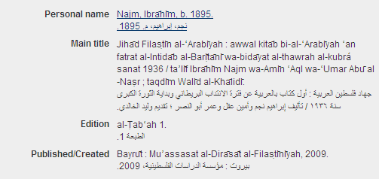

**Why Arabish?**

* For Arabs living abroad with a QWERTY keyboard, Arabish is the only option if they want to communicate with their friends and family
* Arabish is a teen language. It has become an icon and gives teens the Arab identity they are seeking.

**How did Arabish Start?**

* It was first seen in chat rooms when IRC was the only mode of electronic communication
* It was a reaction to the domination of Latin script in the world of technology
* Arabish emerged and spread with the development of the Internet and other technologies like smart phones

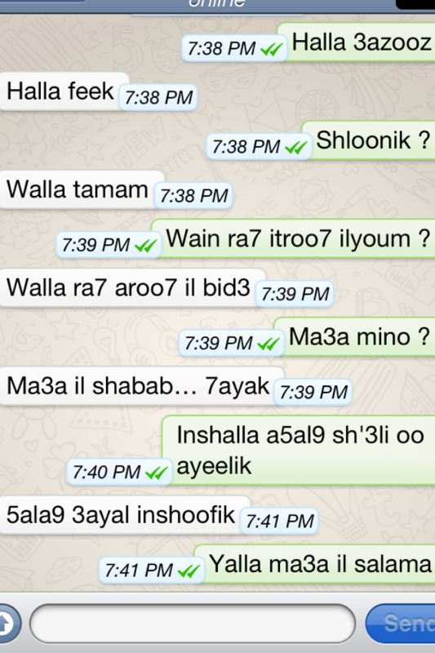**Where is Arabish Used?**

* Whatsapp
* Arabish can be seen in blogs and in chats all over the Internet
* Arabish can be seen in tweets, Instagrams, Facebook, Flickr, Youtube, etc.
* Arabish has become so popular that business and companies have begun to adopt it as an advertising tool.
* It was widely used during the Arab Spring revolutions.

**Why Arabish?**

* It’s easier
* I don’t have an Arabic keyboard
* I want to talk to my friends in slang not in fo97a
* My parents can’t read it
* I’m proud to speak in Arabic…I just can’t type it
* It’s kind of a funky language for teens to use; like a code language
* I can cheat in Arabic tests because the teachers don’t get it
* I can send notes to my friends in class and my teachers won’t get it.

**The Future of Arabish**

* The Internet will continue to have long-term effect on language use as a form of human communication, and Arabish will continue to be used as an informal language amongst teens.
* The online use of Arabic will be shaped by both technical capacities and by the social systems that technology encompasses.
* The online use of English and Arabic by the Arab youth will reflect a broader and more enduring social and linguistic shifts
* Global networks and the local Arab identity will continue to evolve as social media and electronic communication grows.

**References**

"Search Engine Helps Users Connect In Arabic." Martin, Philip. All Things Considered. NPR. 6 July 2009. Web. Transcript

"AME Info, Abu Dhabi, United Arab Emirates, education briefs." Kuwait Times 9 Nov. 2011: 1. EBSCO Host - Newspaper Source. Web. 20 Mar. 2012

Deborah, Viadero. "Text Messaging." Education Week 29.30 (2010): 1. EBSCO Host - Professional Development Collection; Web. 20 Mar. 2012

Mahgoub, Yasser. "English…English …English…The End of the Arabic Language.” Yasser Mahgoub, “Architect. N.p., 18 Jan. 2011. Web. 25 Mar. 2012. <http://ymahgoub.wordpress.com/2011/01/18/english-english-english-the-end-of-arabic-language/>

Moore, Andrew. "Language and technology." Universal Teacher. N.p., n.d. Web. 18 Mar. 2012. <http://www.universalteacher.org.uk/lang/languageandtechnology.htm>

Reshamwala, Shakir. "Arabish Goes Mainstream." Kuwait Times 1 Apr. 2008: 12. EBSCO Host - Newspaper Source. Web. 20 Mar. 2012

Riley-Huff, Debra A., and Julia M. Rhodes. "Librarians and Technology Skill Acquisition: Issues and Perspectives." Information Technology and Libraries 30.3 (2011): 11. Ebsco Host. Web. 19 Mar. 2012

"Growth of Active Twitter Users in the Arab World [Infographic] | Wamda.com." inspiring, empowering and connecting entrepreneurs | Wamda.com. N.p., 4 June 2012. Web. 11 Sept. 2012.<http://www.wamda.com/2012/06/growth-of-active-twitter-users-in-the-arab-world-infographic>.

Palfreyman, David, and Muhamed Al Khalil . ""A Funky Language for Teenzz to Use": Representing Gulf Arabic in Instant Messaging." Journal of Computer-Mediated Communication. N.p., 11 Jan. 2003. Web. 9 Sept. 2012. <jcmc.indiana.edu/vol9/issue1/palfreyman.html>.

"Sami3ny." Zain Entertainment. Zain, n.d. Web. 8 Aug. 2012. <https://www.kw.zain.com/kw/af/core/home/channel.do?channelId=-8195&selectedChannels=-8195,-8157,-8155,-8153&lang=en>.