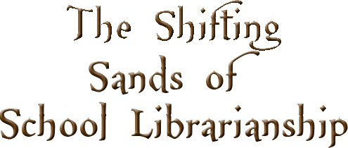

**Photographs: Fatma Al Marzouqi**

especially in the world of education. At the 2012 IASL Conference we will focus on these changes and what they mean to School Librarians around the world.

**Conference Strands**

Internationalism

Collaboration

Creativity and Innovation

Literacies and Fluencies

**Education City Library Directors’ Council – SIG (QISL)**

**in partnership with Qatar Academy**

**IASL 2012 Conference Committee**

Doha, Qatar

http://iasl2012.org

info@iasl2012.org

Join us at the

IASL Conference in

Doha, Qatar

**November 11-15, 2012**

To share, discuss and collaborate about the

Shifting Sands of International School Librarianship

## Things Change…

***Internationalism – Shifting Borders***

**This strand will focus on shifting minds from personal to global perspectives and on encouraging open mindedness and internationalism in our communities.**

***Creativity and Innovation –***

***Shifting Needs, Expectations and Roles***  
  
**Changes in education will accelerate over the coming years, and schools and libraries must reconsider even the most basic assumptions concerning learning goals, methods, and environments.**

***Collaboration – Shifting Relationships***  
  
**These sessions will focus on the development of professional learning networks and the opportunities to assume leadership roles in integrating curricular skills within the learning environment.**

***Literacies and Fluencies – Shifting Definitions***  
  
**The literacy needs of students are intrinsically intertwined with changes in the way knowledge is consumed and created.**

### *We Must Work Together*

### *As We Shift!*

# The Shifting Sands of School Librarianship