Children’s Centre Library Celebrates ISLM 2018 in Nigeria

Children’s Centre Library at the University of Nigeria celebrated ISLM through a series of school visits during the month of October, culminating in a grand finale at the Centre on Nov. 5, 2018. Our focus was finding a way to explore the 2018 theme—Why I Love My School Library—with children attending schools without libraries. To achieve this we embarked on a program of weekly story hour visits to five public primary schools in the area, during which a team of four—Grace Onyebuchi, Elizabeth Babarinde, Evangel Obim and Judith Ezegwu— shared books and knowledge about diverse cultures with pupils in primary grades 3-6. This program was informed by the ISLM 2018 option of exploring another country or culture through the resources of the library. In this case we shared stories and information resources from the Children’s Centre Library with children from nearby primary schools. Each team member focused on cultures within a broad geographic area: East and Southern Africa, Europe, Asia and South America. By this means, pupils in the four upper grades were able to learn something about a different culture while also exploring certain universal themes relevant to children everywhere. They also became more aware of the variety and value of library resources.

The five schools were Model 2 Primary School in the center of Nsukka Town, Isiakpu Community Primary Schools 1 and 2 in a nearby rural community, and Onuiyi Community Primary Schools 1 and 2 in a neighborhood near the university campus. Of these only Model 2 has a school library, though this has been closed for some time due to lack of staff. Varied learning resources are lacking in all the schools and the classroom environment is poor. Through enjoying shared reading and learning experiences during ISLM, the Children’s Centre was able to stimulate interest in reading and awareness of school libraries.

A grand finale took place in the Children’s Centre on November 5 on the ISLM theme: Why I love my school library. Twenty pupils from each school, or a total of 100 were invited to this culmination of the month’s activities. While waiting for buses to arrive from the various schools, children were free to explore library resources, including books, puppets from world cultures, and a display of children reading everywhere.

The program combined reading and social experiences with interactive talks. In her welcome address,Committee Chair Ngozi Osadebe invited children to mix with those from other schools and make new friends. Pupils then shared accounts of new friends made and books they especially remembered from the school visits. Following thisElizabeth Babarinde shared a Nigerian folktale, Why Mosquitoes Buzz in People’s Ears and led singing activities. Evangel Obim focused on Developing a reading culture; while Grace Onyebuchi discussed Why I love my school library. After a lively musical interlude led by Florence Chukwurah, Grace introduced children to the educational use of social media. Ngozi Osadebe concluded with introduction of the bookmark program, which is focusing on sharing Nigerian culture with children in other lands; Children’s Centre has now been paired with two schools and is concluding that aspect of ISLM. Refreshments and a group photo ended the grand occasion.

It is hoped that the interest and excitement about books and reading stirred by this program will build toward efforts to develop school libraries and encourage the use of varied resources in education.
School Visits by Children’s Centre Library

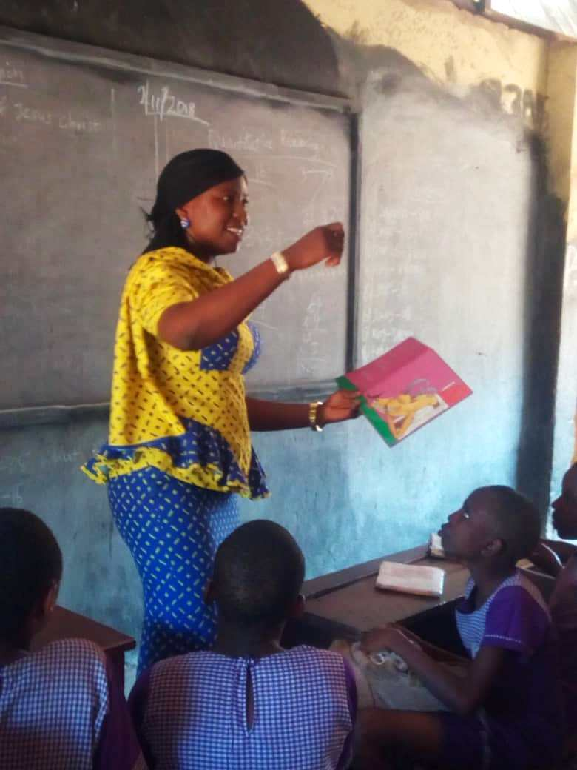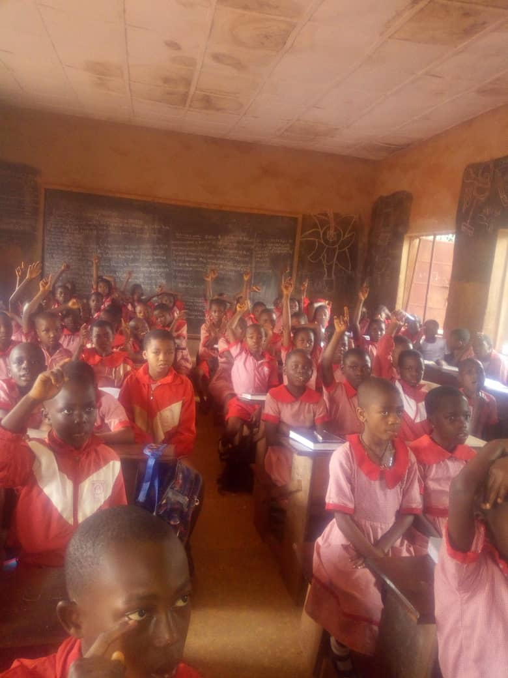
Storytelling by Grace Onyebuchi Pupils at Model P. S. 1, Nsukka

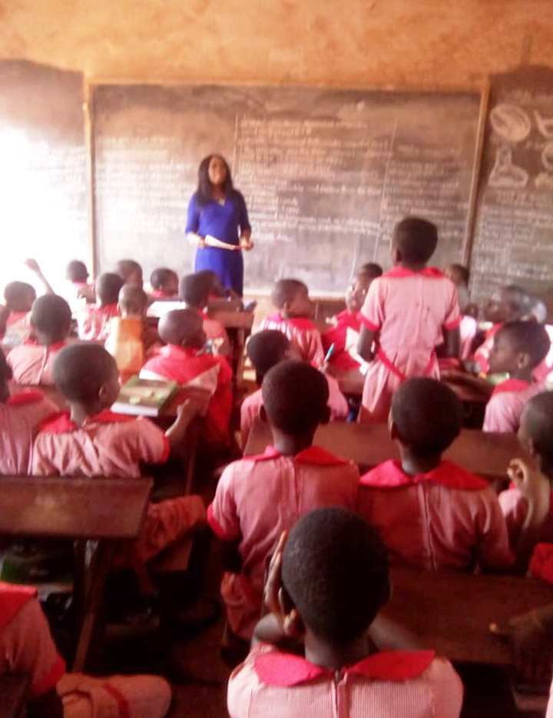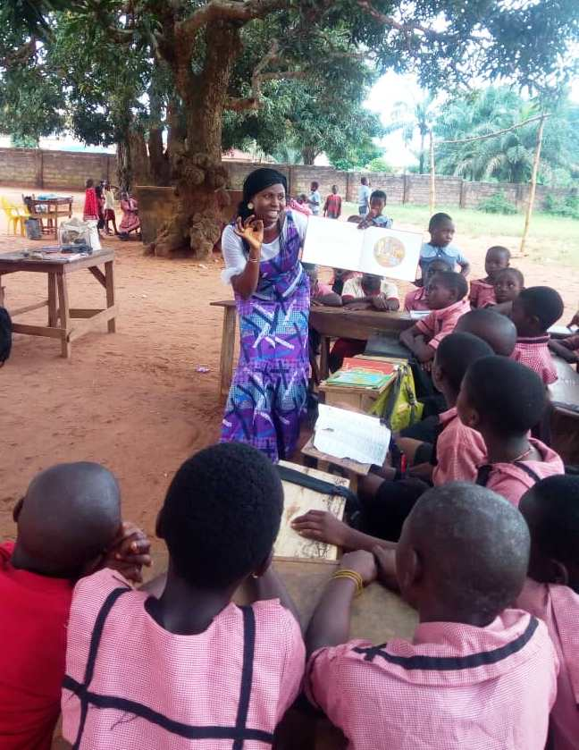
Evangel Obim with pupils at Model P. S. 1 Grace Onyebuchi at Isiakpu schools

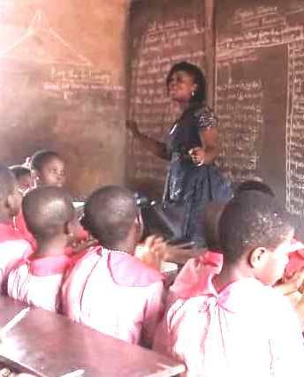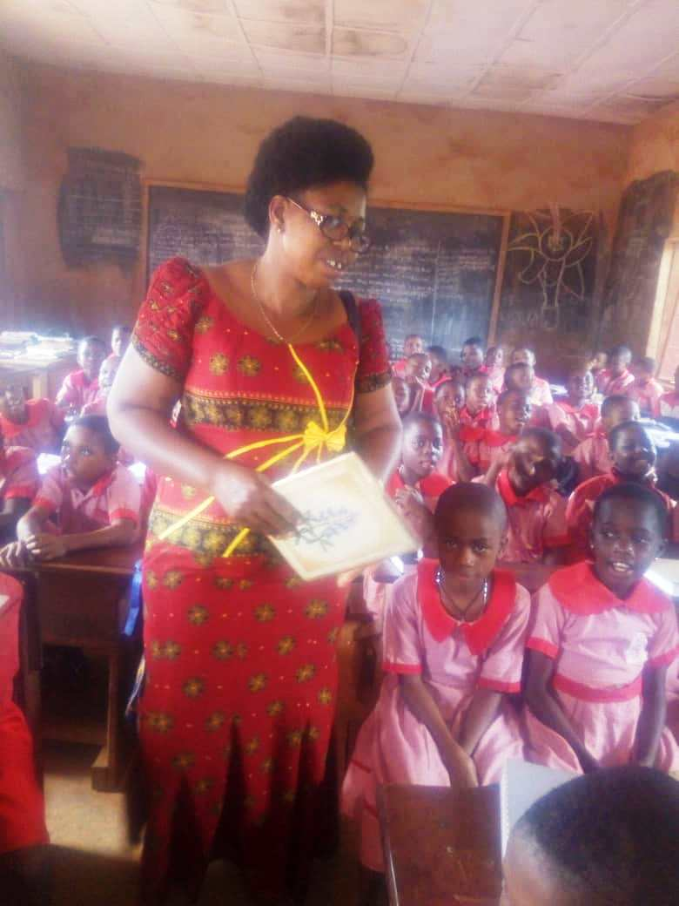
Storytelling with Elizabeth Babarinde Judith Ezugwu sharing a folktale

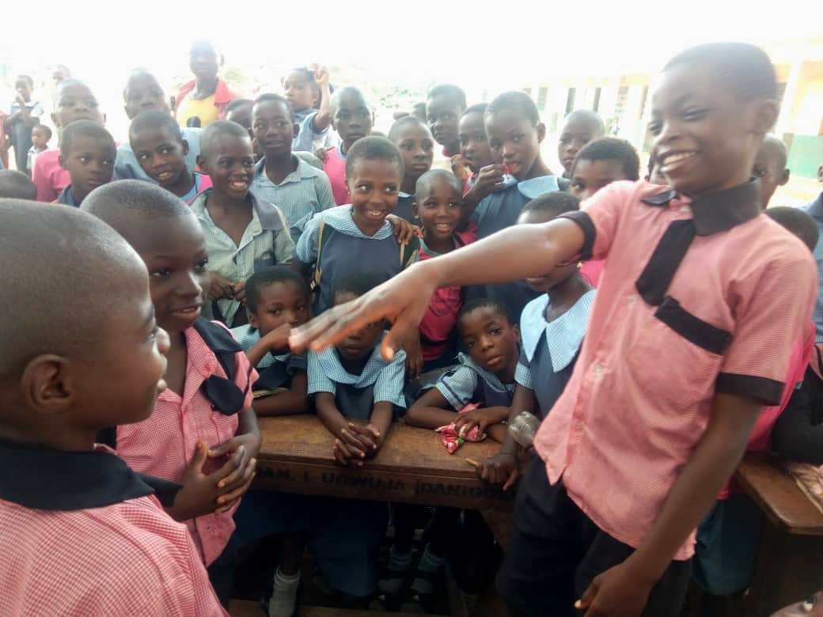
Pupils at two Isiakpu primary schools

Grand Finale of ISLM at Children’s Centre Library

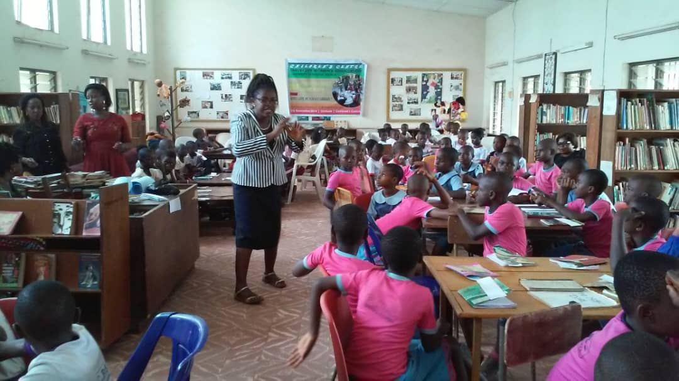
Ngozi Osadebe welcomes pupils from the five schools to Children’s Centre Library

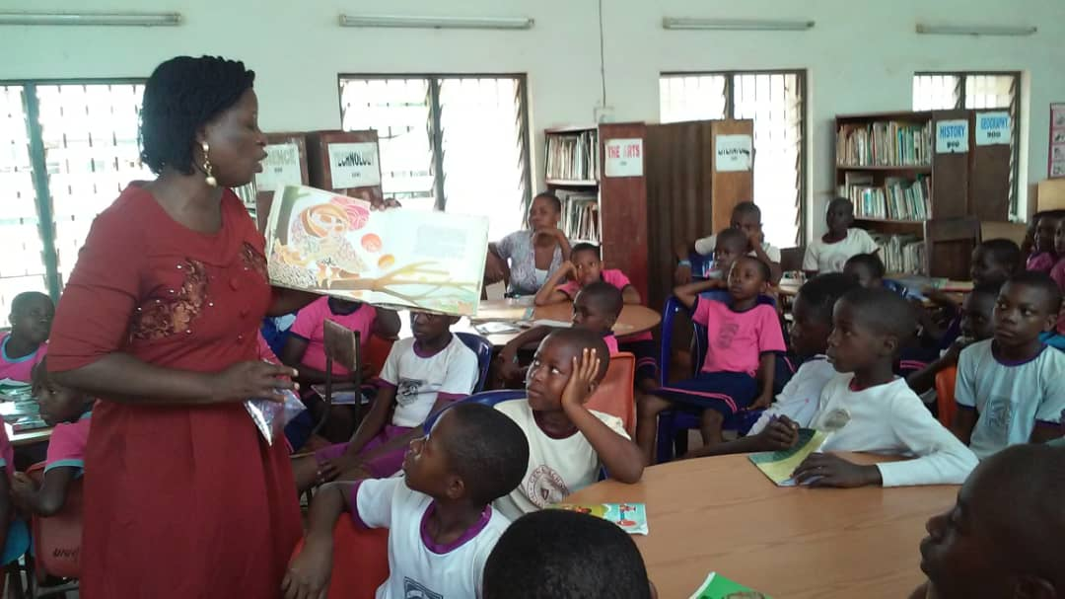
Elizabeth Babarinde shares a Nigerian folktale, Why Mosquitoes Buzz in People’s Ears

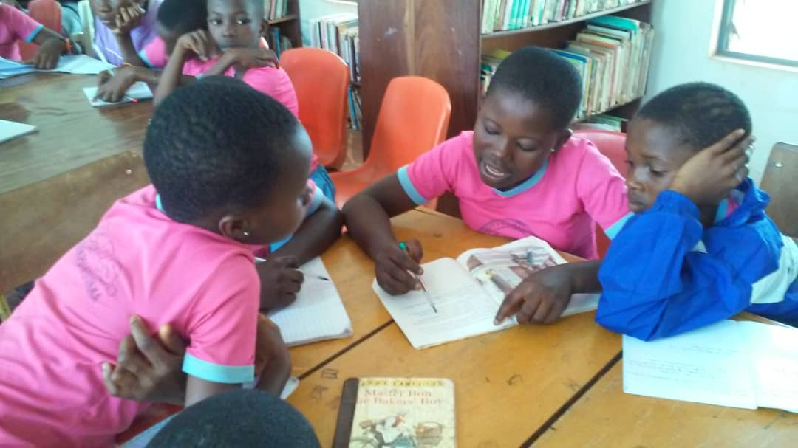
Children exploring the library’s collection

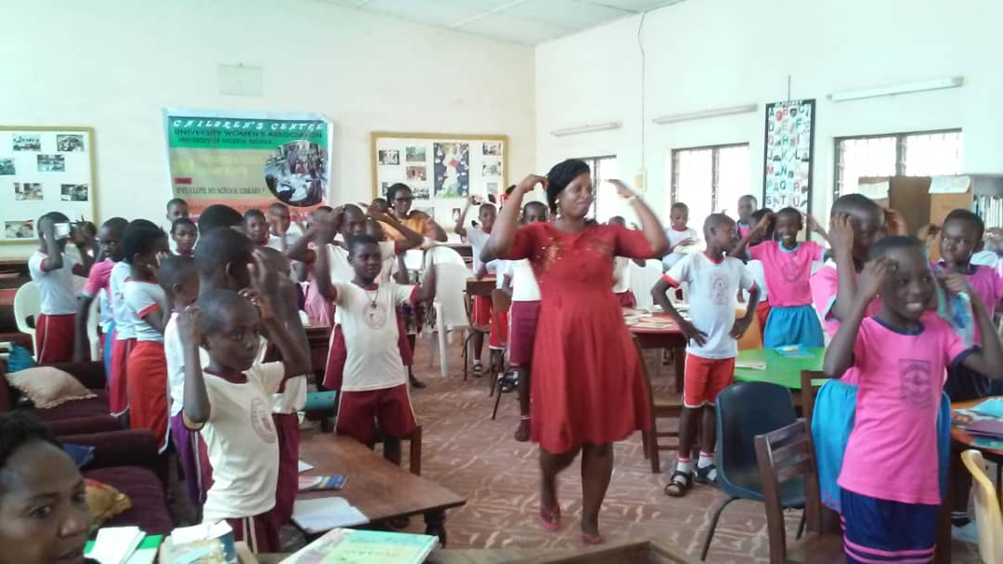
Singing led by Elizabeth Babarinde

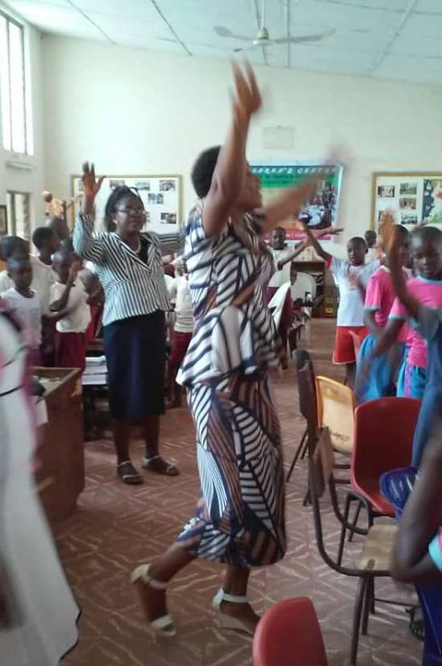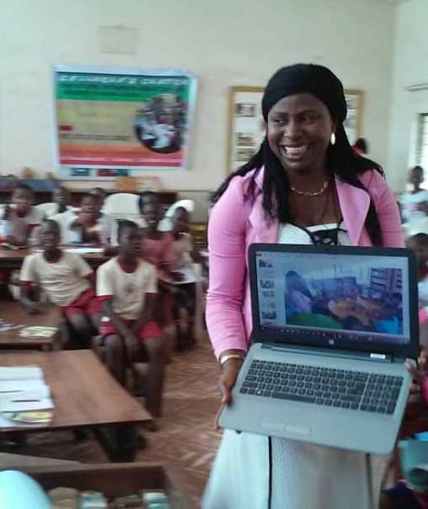
Like a butterfly with Florence Chukwurah Grace on Why I Love My School Library

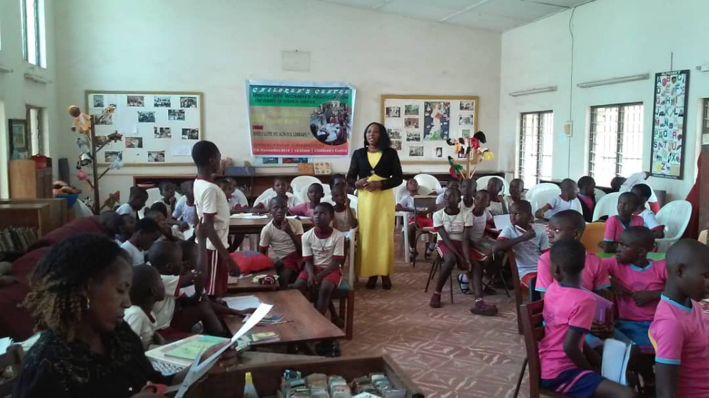
Evangel Obim explores ways of developing reading culture with the children

