Country: Romania
Name: Daniela Dorcu
Position: School Librarian
Organization: „D.A. Sturdza” Middle School from Iasi
http://scoaladasturdza.ro/
https://www.facebook.com/%C5%9Ecoala-Gimnazial%C4%83-Dimitrie-A-Sturdza-Ia%C5%9Fi-141067859350914/

During the month of October, the International Month of School Libraries, students from ”D.A. Sturdza” Middle School, Iasi, Romania, have celebrated through several activities that highlighted their creativity, talent and knowledge.
The class of preschoolers B, coordinated by miss Irina Bârceanu, the I-st class A, coordinated by Mrs. Brăescu Paula, the II-nd class A and C, coordinated by Mrs. Simona Lutinc and Mihaela Dîmbu,the III-rd class C, coordinated by Mrs. Carmen Tudorache and the IV-th class C, coordinated by Mrs. Loredana Ştefan, have participated in an activity which involved exchanging bookmarks with pupils from Croatia, Estonia, Portugal and Hungary. This was a new opportunity for our pupils to learn new things about these places and cultures and to inform other students about our city and school.
Also, this month, like the previous years as well, the students form I st class A and Mrs. Paula Braescu have organized competitions between all the classes in the school. This particular competition was called „Donate a book for the school’s library” and the class that donated the most books won a cake.
Classrooms VIth and VIIth, coordinated by the Romanian Language teachers, Ionela Ene and Olaru Mihaela and the librarian Daniela Dorcu have participated in a book presentation contest called ”Go and read!”.
All the above mentioned pupils and teachers have participated with much enthusiasm in all the activities and are already making plans for the next year.
We would like to thank all the projects’ organizers for the occasion they have offered to school libraries to emphasize their importance in the process of education.

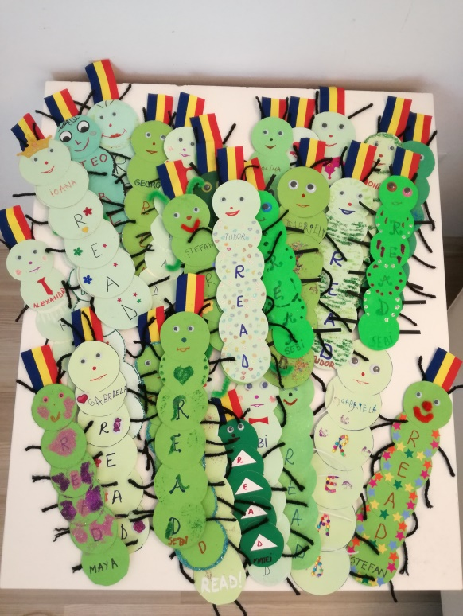
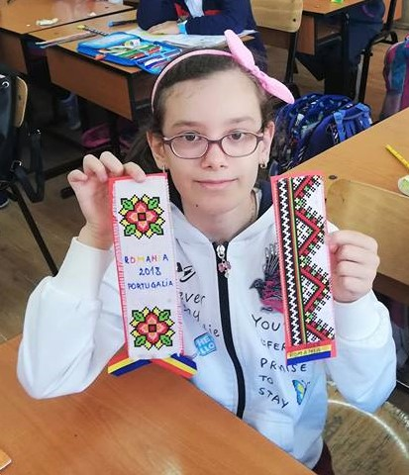

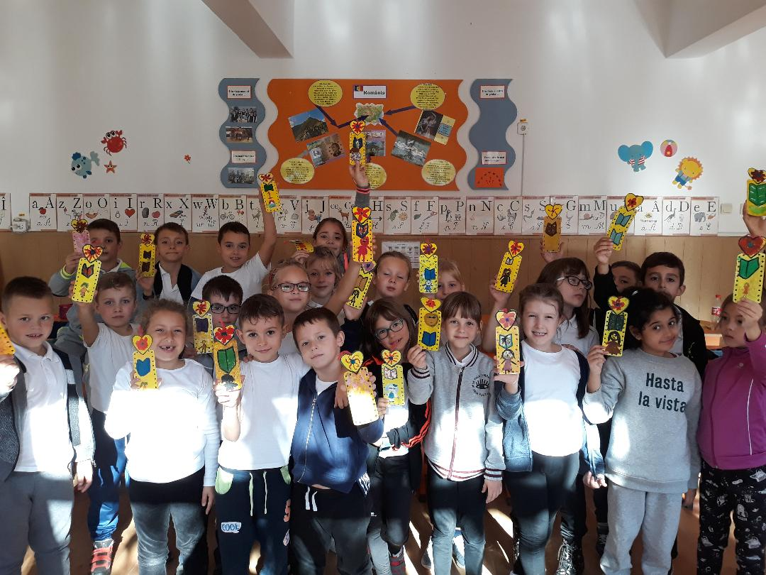

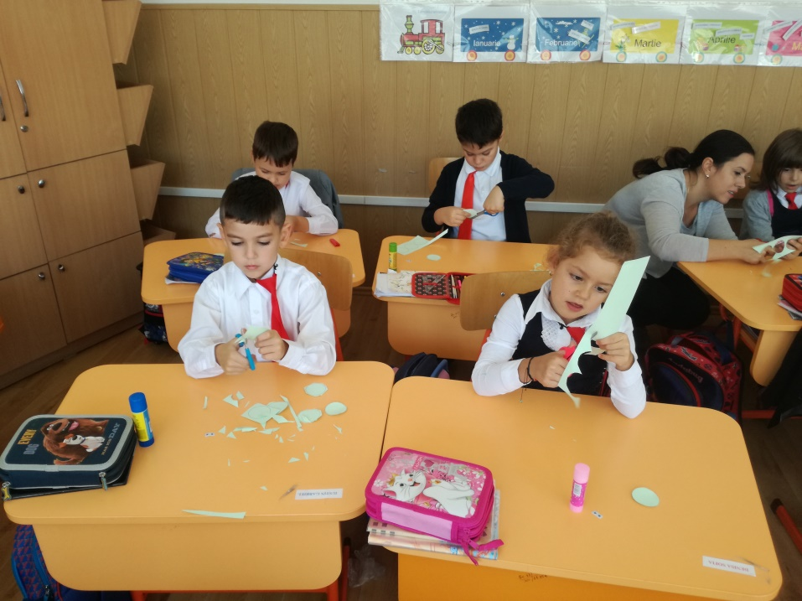

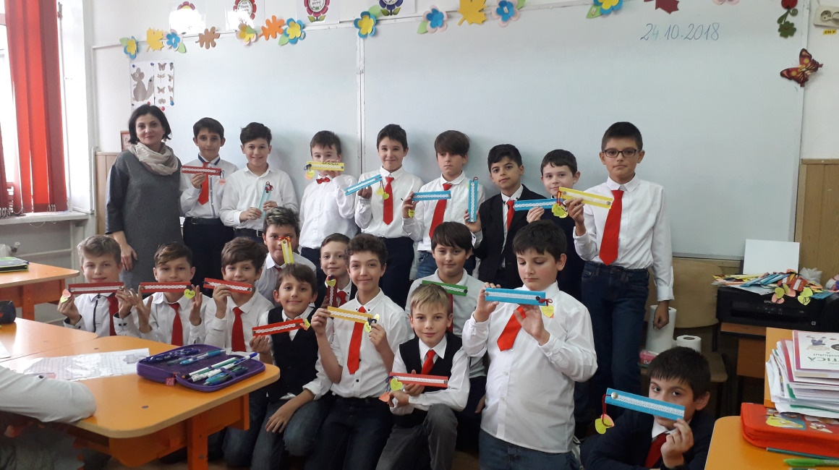

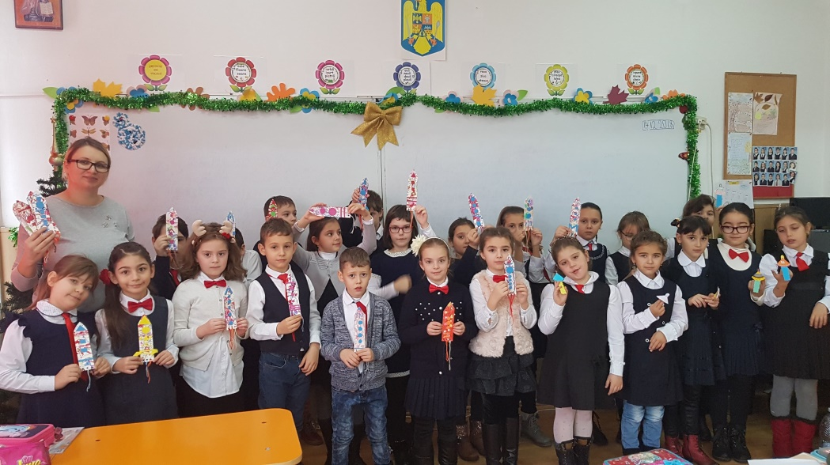

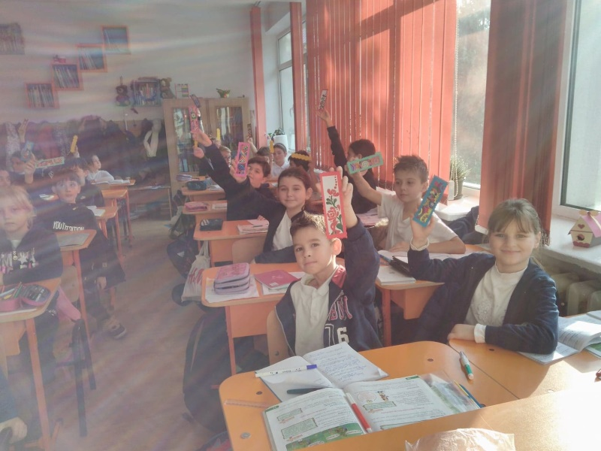

BOOKMARK EXCHANGE PROJECT

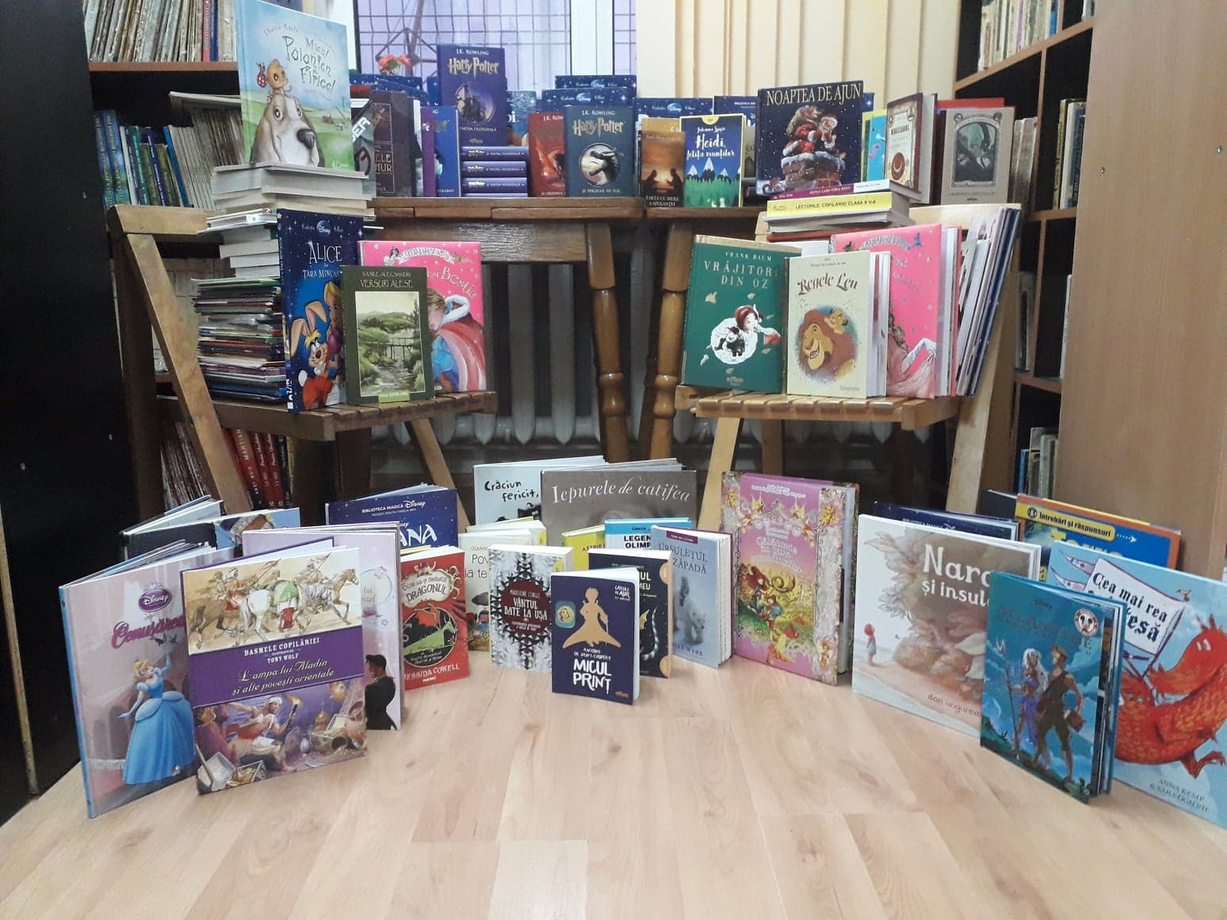

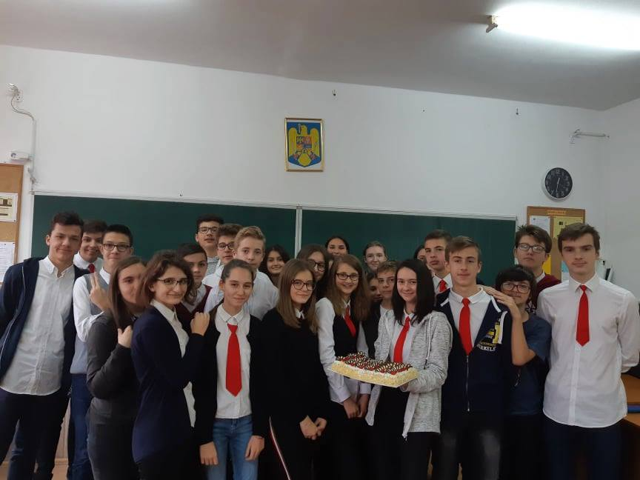

„DONATE A BOOK FOR THE SCHOOL’S LIBRARY”

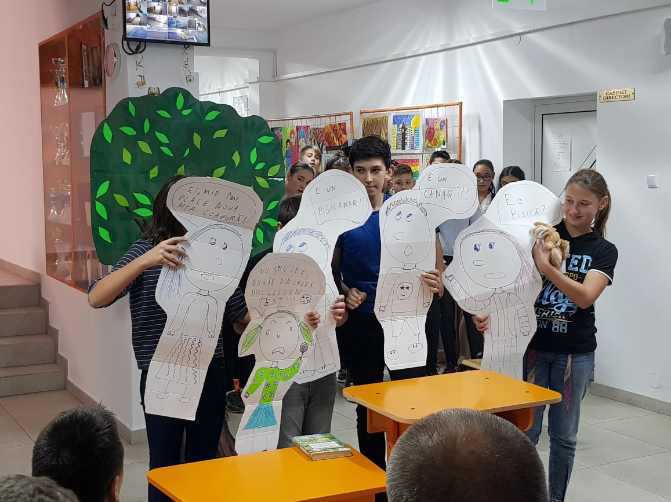

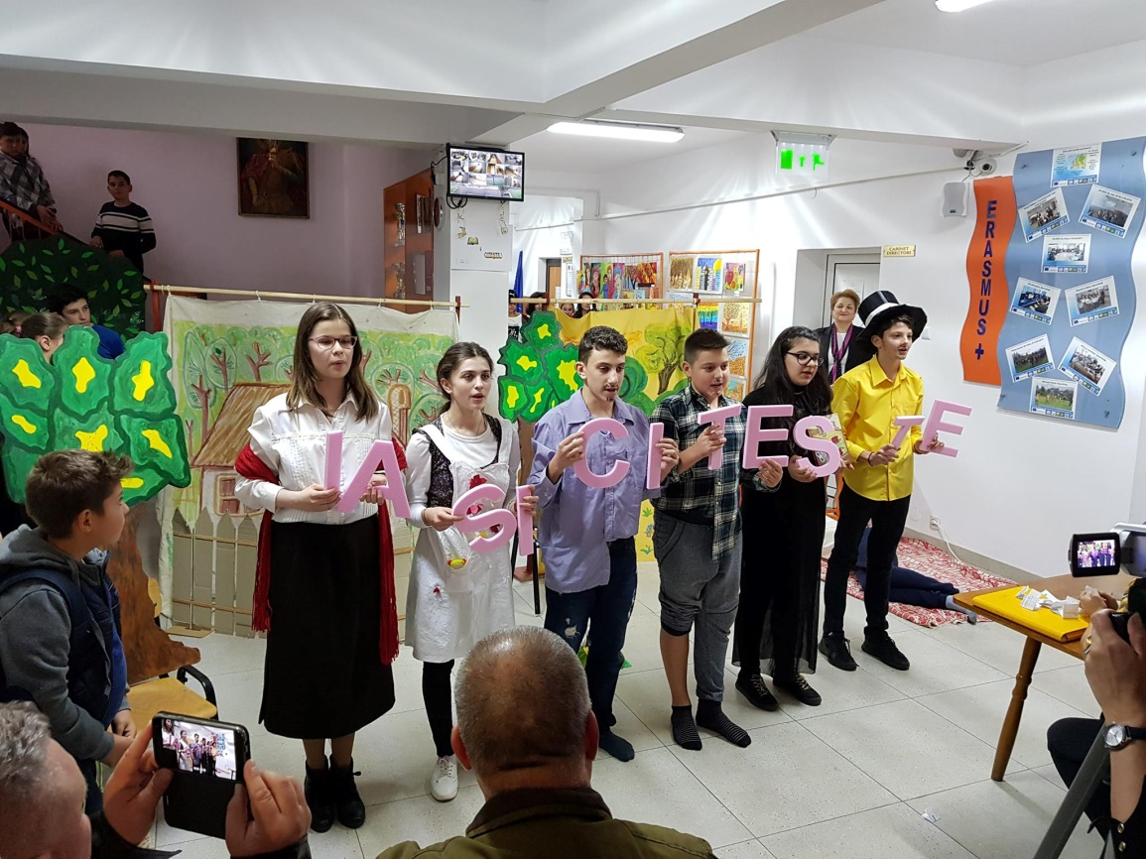

”GO AND READ!”

