Country: Croatia
Name: Dubravka Payerl
Position: Teacher-librarian / School librarian
Organisation: Ivana Brlić Mažuranić Elementary School, Koška

International School Library Month – READING AND IMAGINING
SCHOOL LIBRARY ACTIVITIES
LOWER GRADES
Reading of the story Space Race (5-minute Tales, Bedtime Stories)
Danko and the Dreamy Dinosaur (5-minute Tales, Stories for Boys)
Sleepy Stories – Three Friends
Good Night, Kids; Ela Peroci – Reading of the story Clef – 2. grade
Music is in the background of every activity
Croatian Tales of Long Ago by Ivana Brlić Mažuranić – Regoč – 4. grade
Reading aloud the paragraph on Kosjenka the Fairy, who throws pearls, imagines and fulfills wishes and overcomes obstacles on the way.
A pearl game – Tell us what you're dreaming about! Throw the pearl in the basket, imagine a wish and say it!

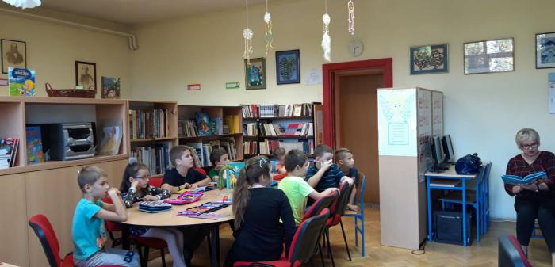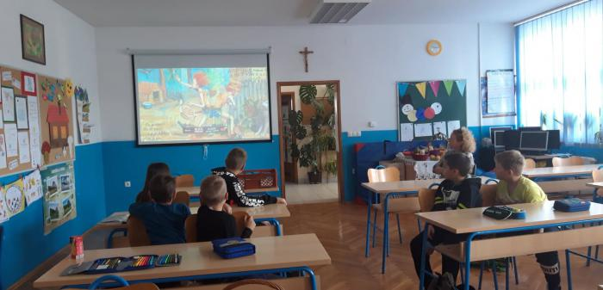

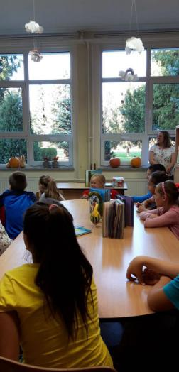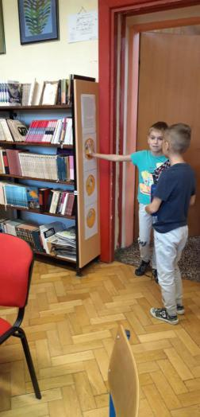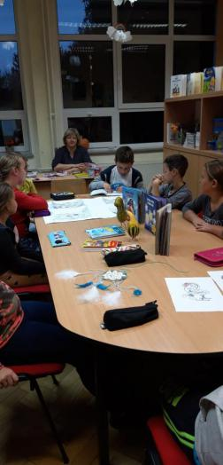

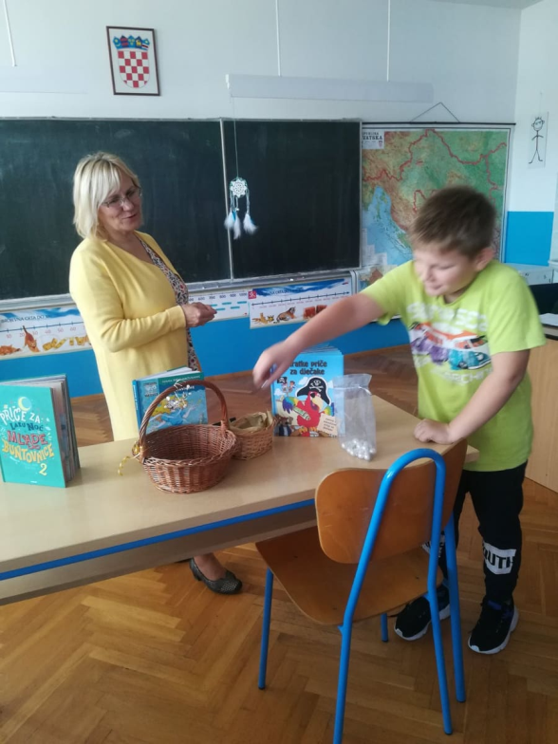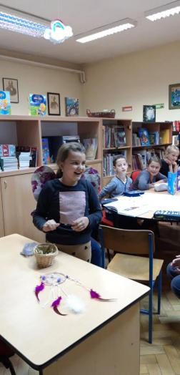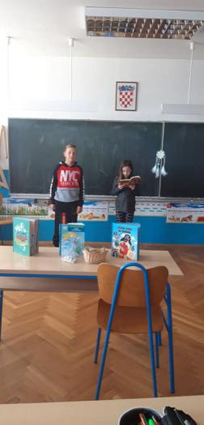
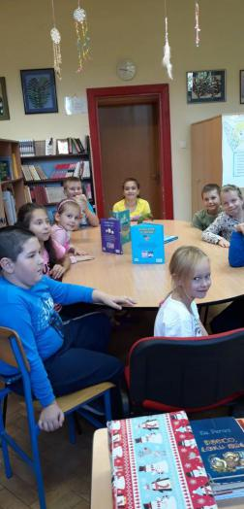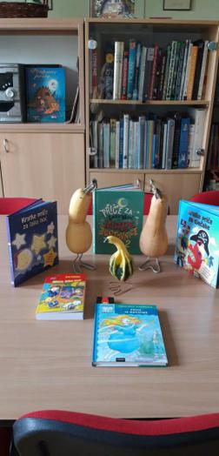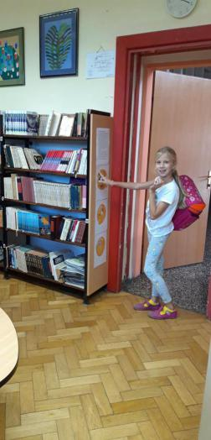

HIGHER GRADES

Imagination as the Driving Force – researching sayings and texts on imagination and dreams; discussion and poster making – 7. and 8. grade
Reading out loud Good-Night Stories for Young Rebel Girls 2, F Cavalo, E. Favilli – 5. and 6. grade
Discussing J. K. Rowling (the author) and her motivational speech On the Power of Imagination and Benefits of Failure.
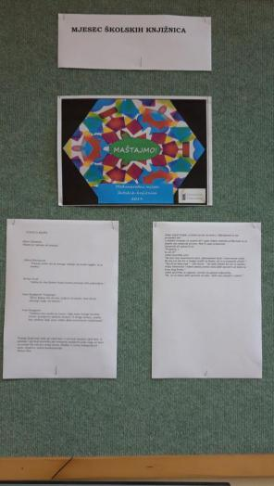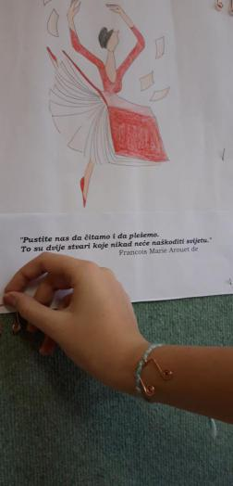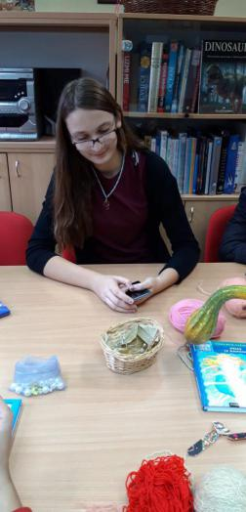
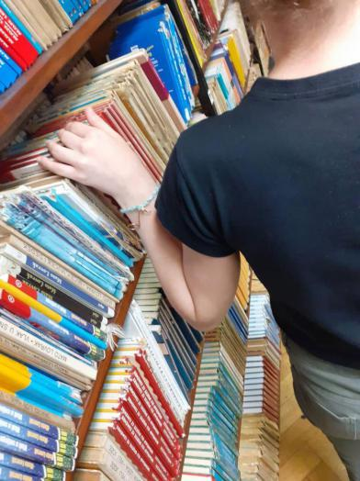

YOUNG LIBRARIANS GROUP

DREAM-CATCHER, IMAGINATION-CATCHER – Making dream-catchers out of wool, wire, feathers and beads
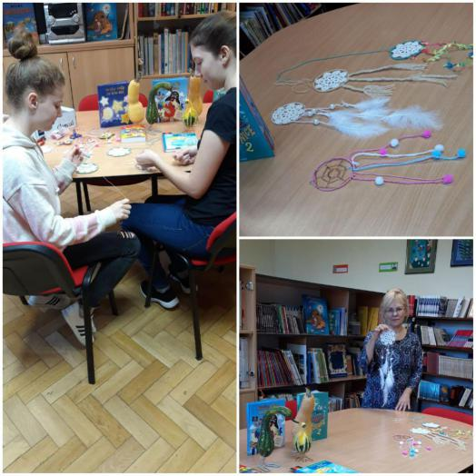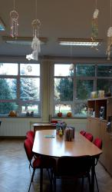

SUN-CATCHERS – making sun-catchers out of glass, shells and necklaces
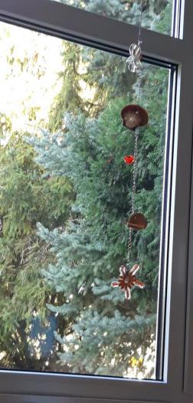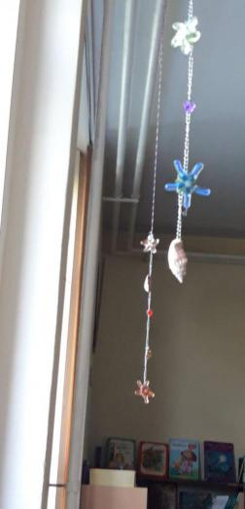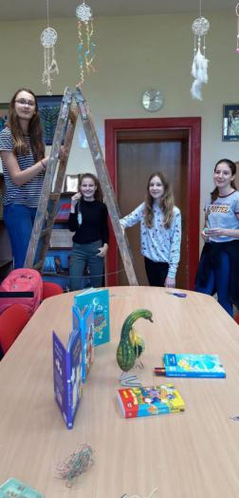

There are those who work all day. Those who dream all day. And those who spend an hour dreaming before setting to work to fulfill those dreams. Go into the third category because there's virtually no competition.
Steven Ross
We put glass, necklace and shell sun-catchers in front of the window to catch the light and magically illuminate the reality.
Third grade students have connected imagination and music workshops with song at the school library. You can see and listen to them here: https://www.youtube.com/watch?v=S8CdN0rfv9E

