- Country:INDIA
- Name :Pankaj Kumar
- Position:Principal
- Organization: Prathmik Vidyalaya Kamhariya,Block-Barhni,Distt- SIDDHARTHNAGAR,State-UP,INDIA

First time this year my school participated for celebration.Thirty bookmarks were made by our children’s and handmade creation as the theme”Let’s Imagine” decided by the IASL for 2019.Our organization sent the bookmarks to the partner country via INDIA POST.Some peculiar pictures mentioned here for your reference.The partenerd country are-1.CROATIA and 2.Australia.
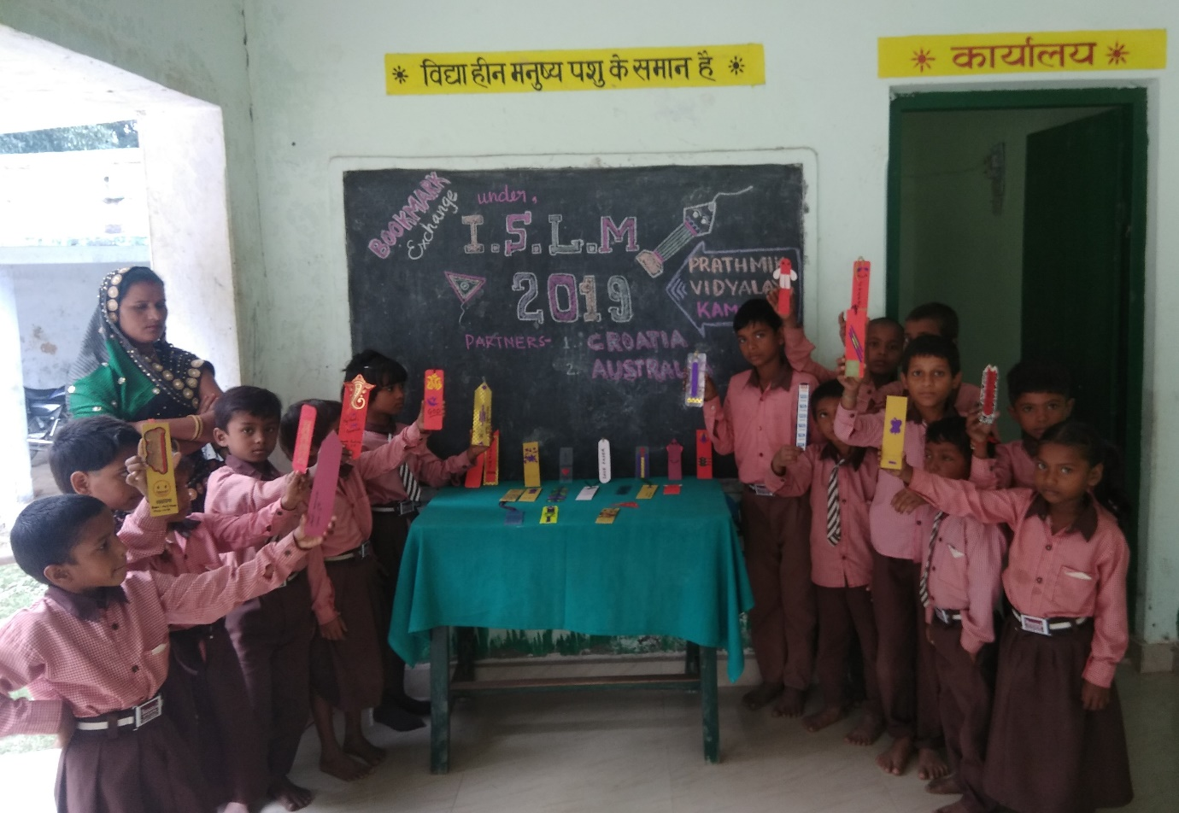
Pic-(1) Bookmark exhibition by the Children’s

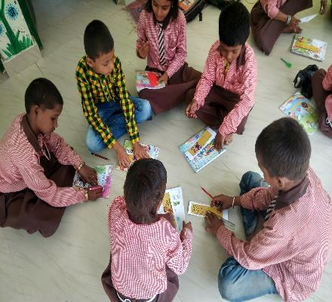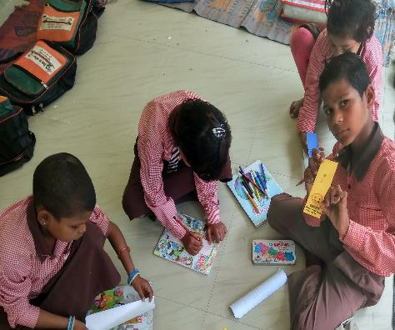
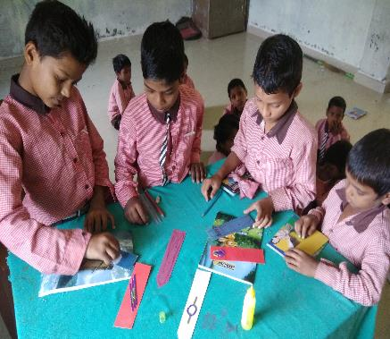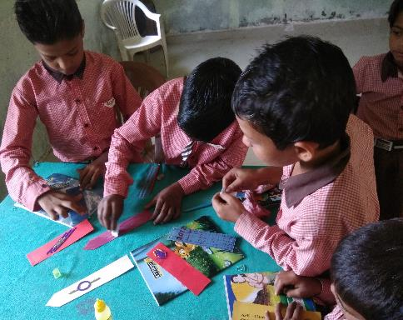
Pic(2,3,4,5)-Bookmark designing by the children’s
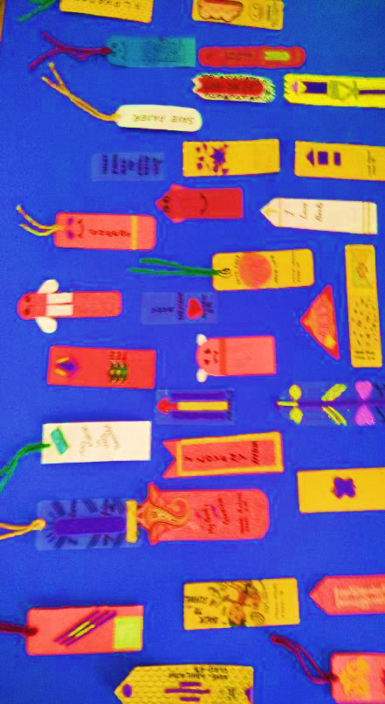
Pic-(6)Bookmarks
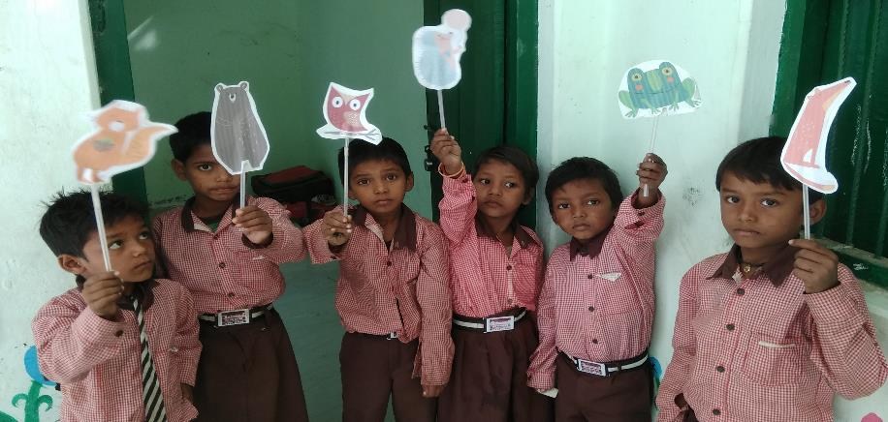

NEWS PAPER CLIP FROM AMAR UJALA HINDI
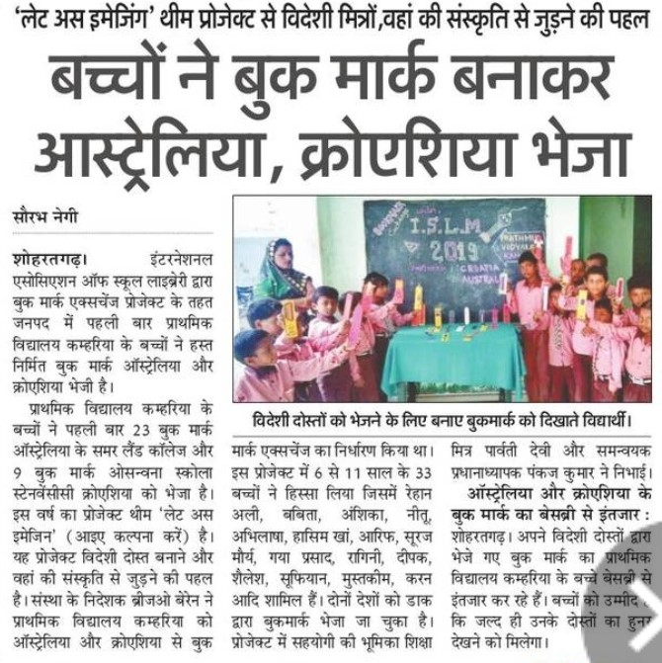
POST
INDIA POST
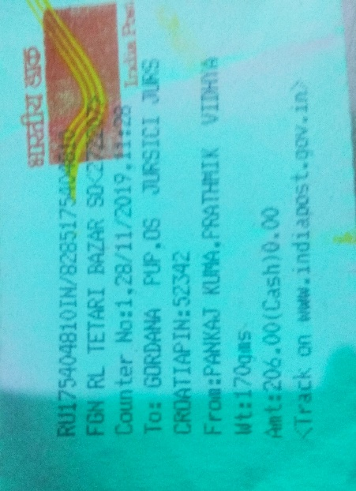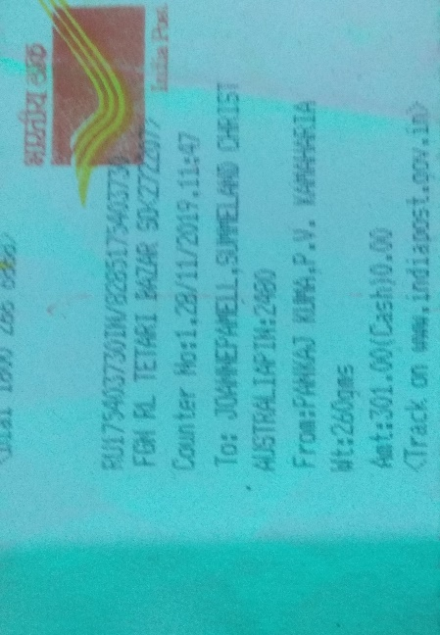

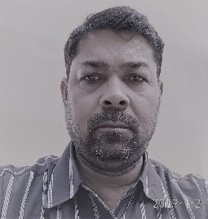
PANKAJ KUMAR
