Country: Romania
Name: Daniela Dorcu
Position: School Librarian
Organization: „D.A. Sturdza” Middle School from Iasi
http://scoaladasturdza.ro/
https://www.facebook.com/%C5%9Ecoala-Gimnazial%C4%83-Dimitrie-A-Sturdza-Ia%C5%9Fi-141067859350914/

During the month of October, the International Month of School Libraries, students from ”D.A. Sturdza” Middle School, Iasi, Romania, have celebrated through several activities that highlighted their creativity, talent and knowledge.
The students from class of preschoolers C coordinated by miss Loredana Ștefan, their teacher, visited for the first time the school library and found out what is a library and how important is for students.
The I –st class B and C, coordinated by miss Viorica Chirilă and miss Irina Bârceanu, the II-st class A, coordinated by Mrs. Brăescu Paula, the III-nd class A and B, coordinated by Mrs. Simona Lutinc and Veronica Maxim, the IV-rd class C, coordinated by Mrs. Carmen Tudorache and the preschoolers class C, coordinated by Mrs. Loredana Ştefan, have participated in an activity which involved exchanging bookmarks with pupils from Croatia, Estonia, Portugal, India and U.S.A. This was a new opportunity for our pupils to learn new things about these places and cultures and to inform other students about our city and school.
Class VI-th and VII-th, coordinated by the Romanian Language teachers, Ionela Ene and the librarian Daniela Dorcu have participated in a book presentation contest called ”Go and read!”.
All the above mentioned pupils and teachers have participated with much enthusiasm in all the activities and are already making plans for the next year.
We would like to thank all the projects’ organizers for the occasion they have offered to school libraries to emphasize their importance in the process of education.

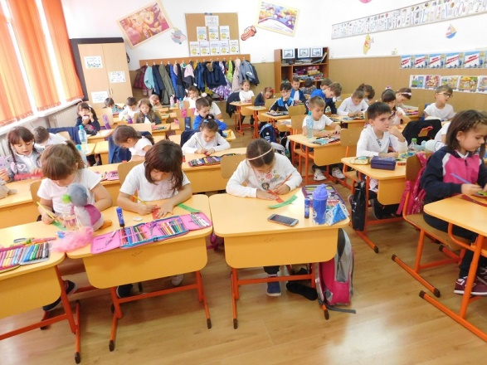
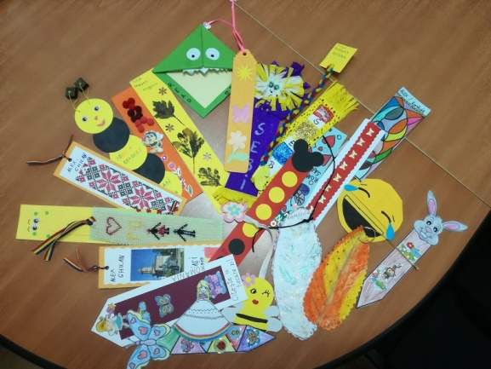

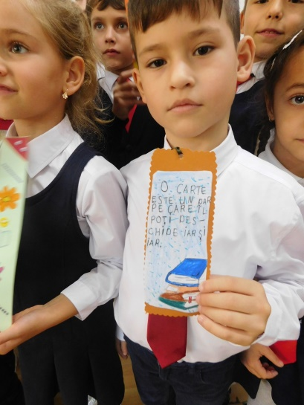

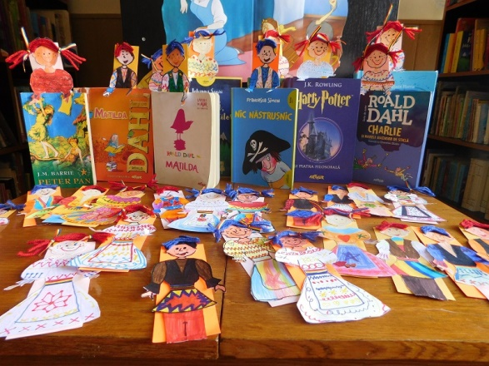

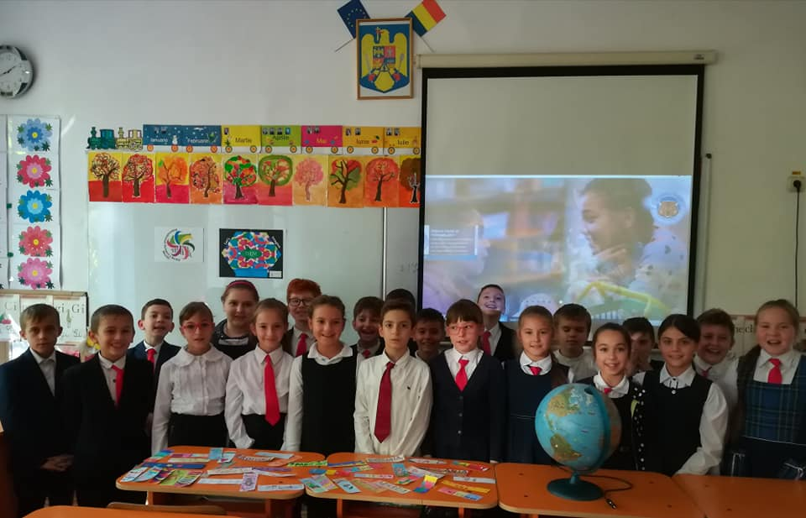
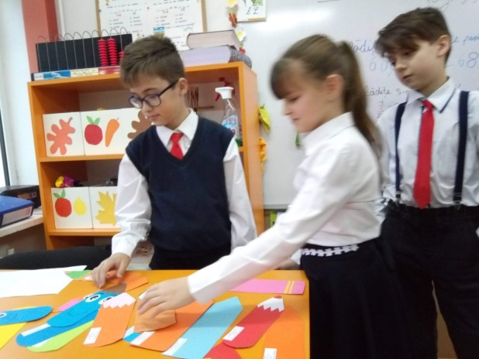

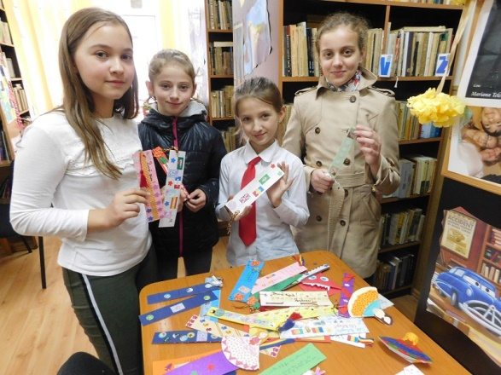

BOOKMARK EXCHANGE PROJECT
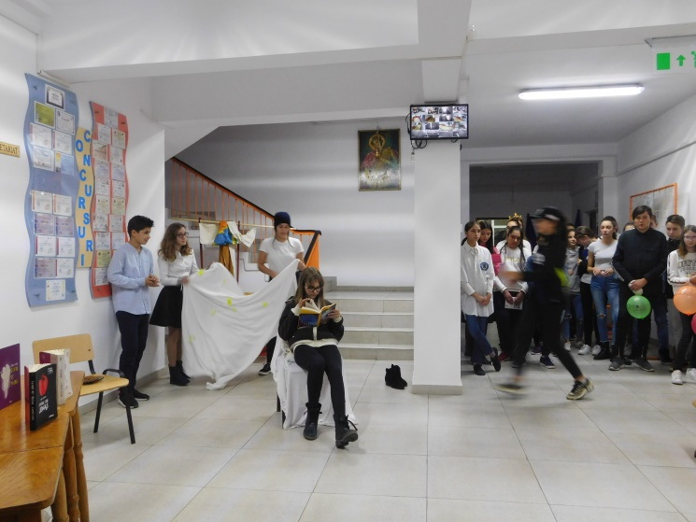

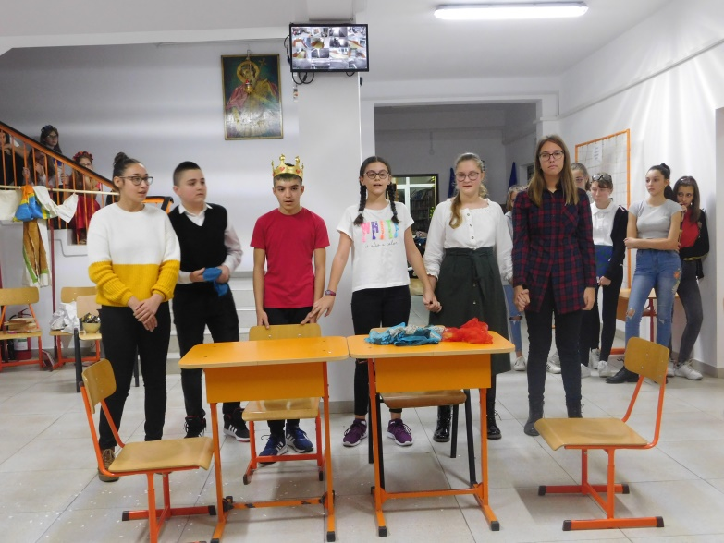

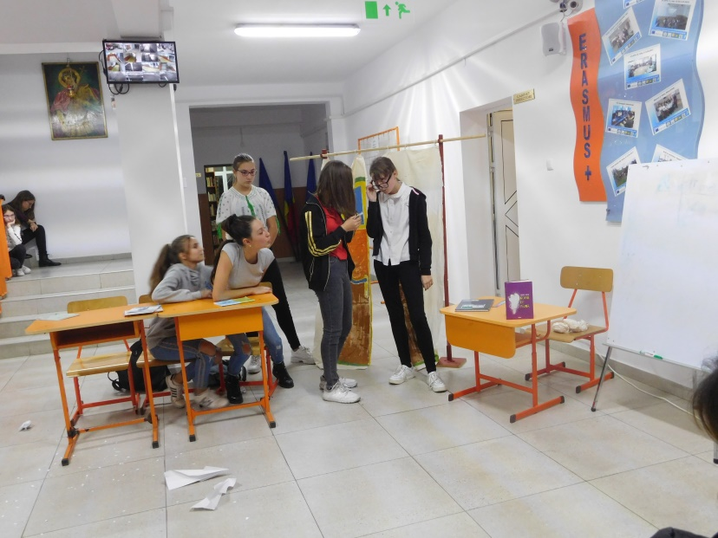

”GO AND READ!”
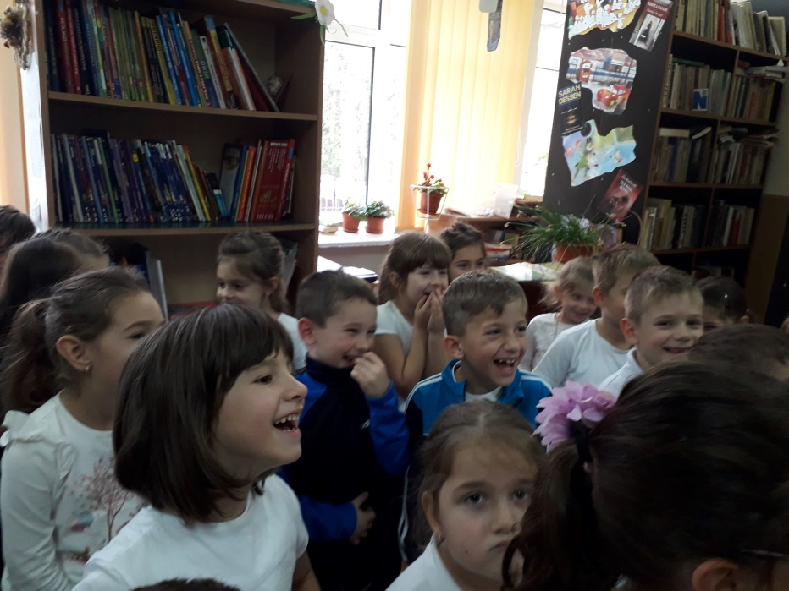

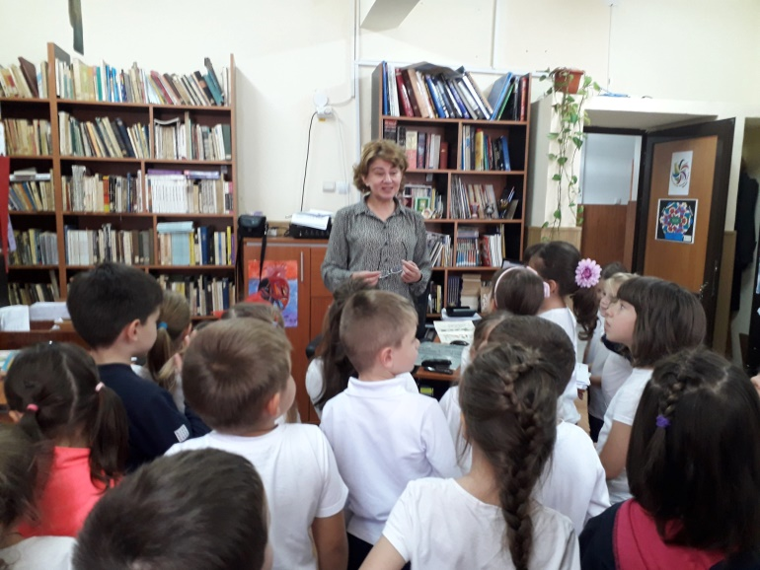
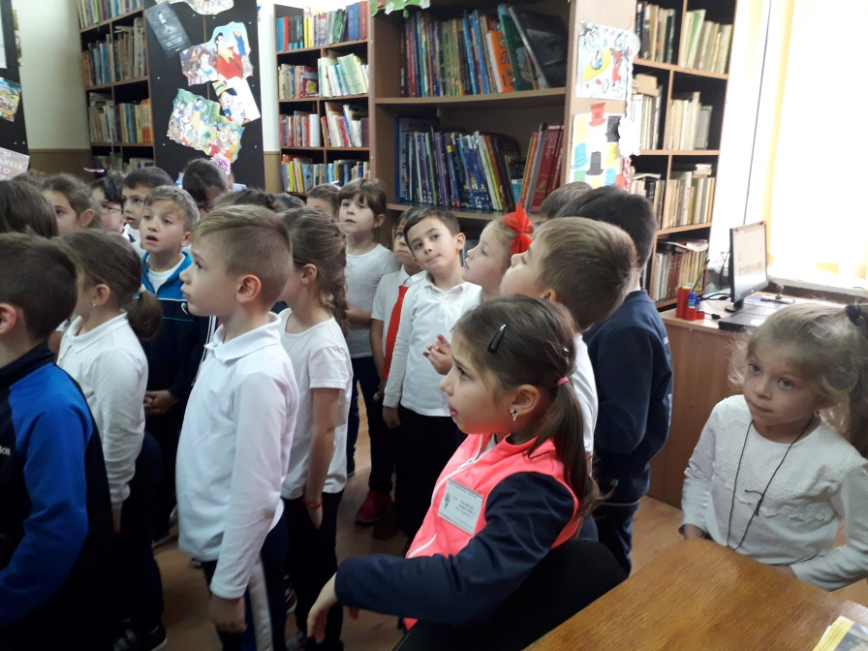
”MY FIRST VISIT TO SCHOOL LIBRARY”

