Country: ROMANIA
Name : Marcu Hajnal
Position: Teacher Librarian
Organization: “Gheorghe Sincai” Middle School from Floresti, Cluj

International School Library Month was dedicated to the school library and various activities were planned to mark the festival of books and reading. ISLM project was fun filled month with children where in the students participated in many activities to renew their love of books.
Our students (2nd class) participated in the ‘International Bookmark Exchange Project’ and exchanged their handmade bookmarks with the following schools:
Agrupamento de Escolas de Fajoes, Portugal
Agrupamento de Escolas de Rates, Portugal
Workshop to make bookmarks:
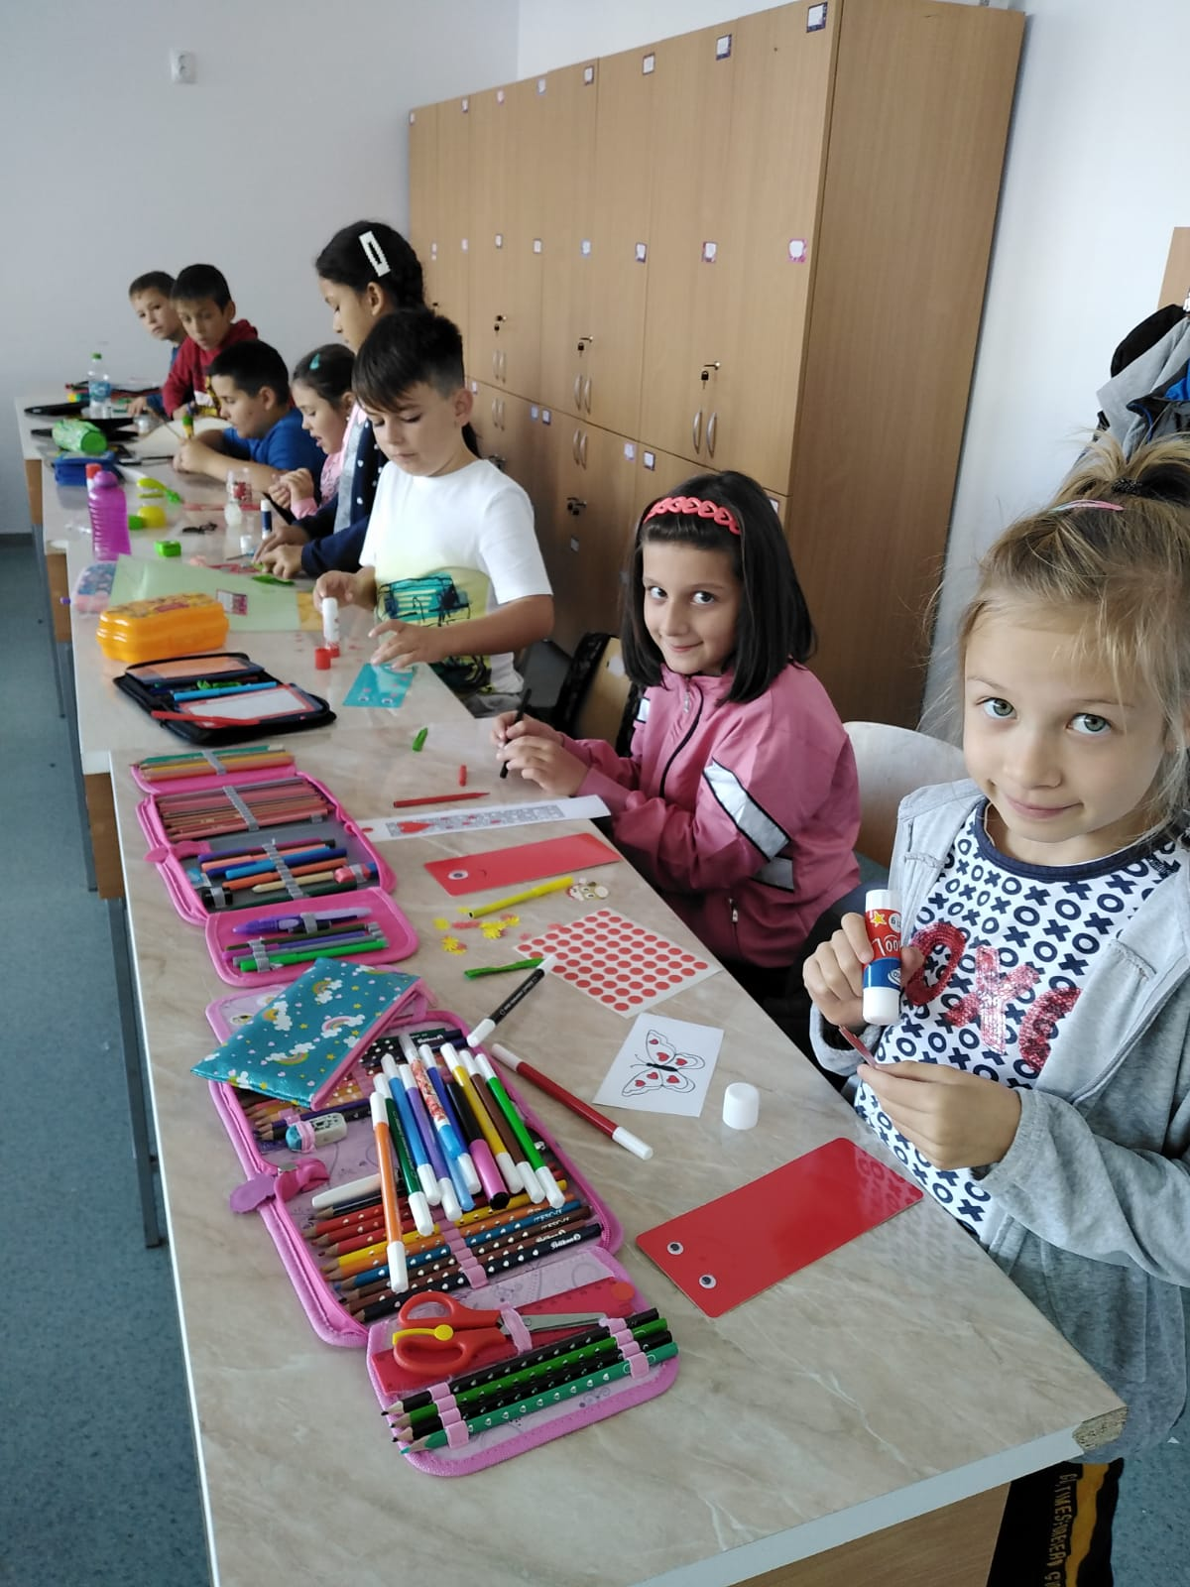
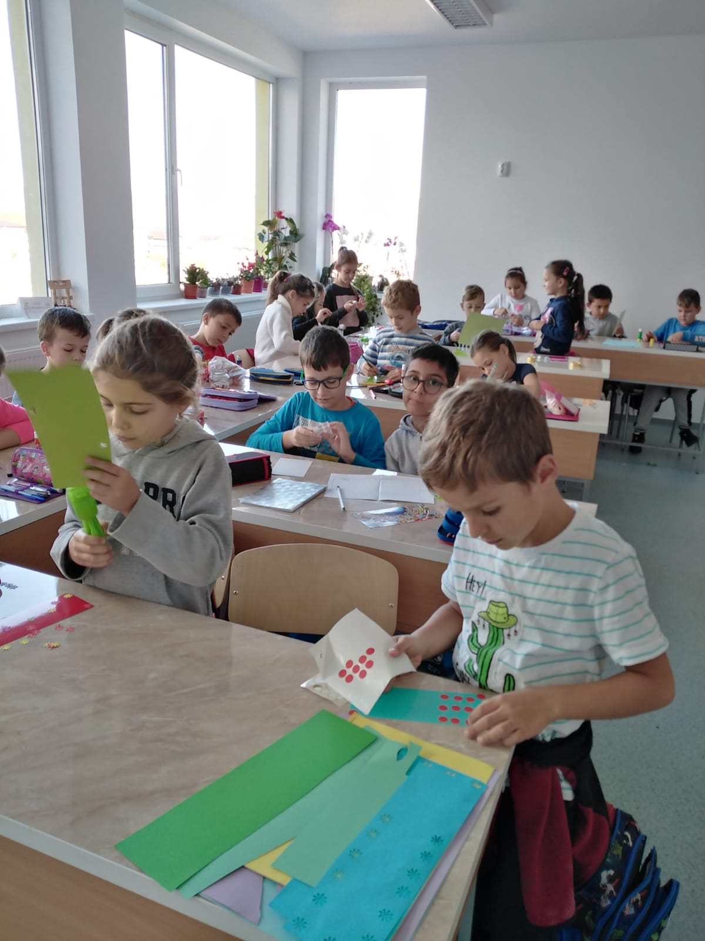

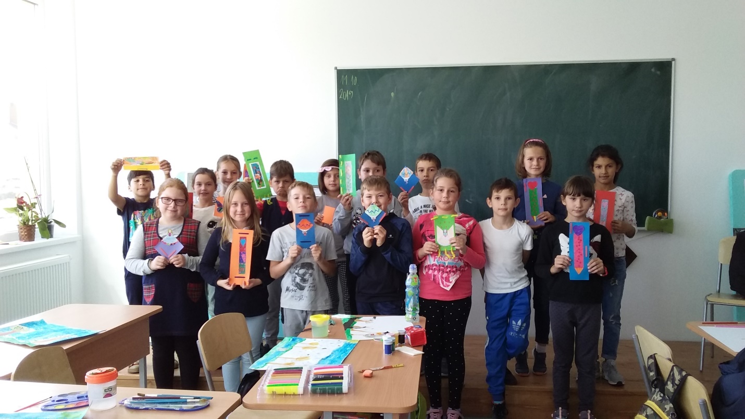
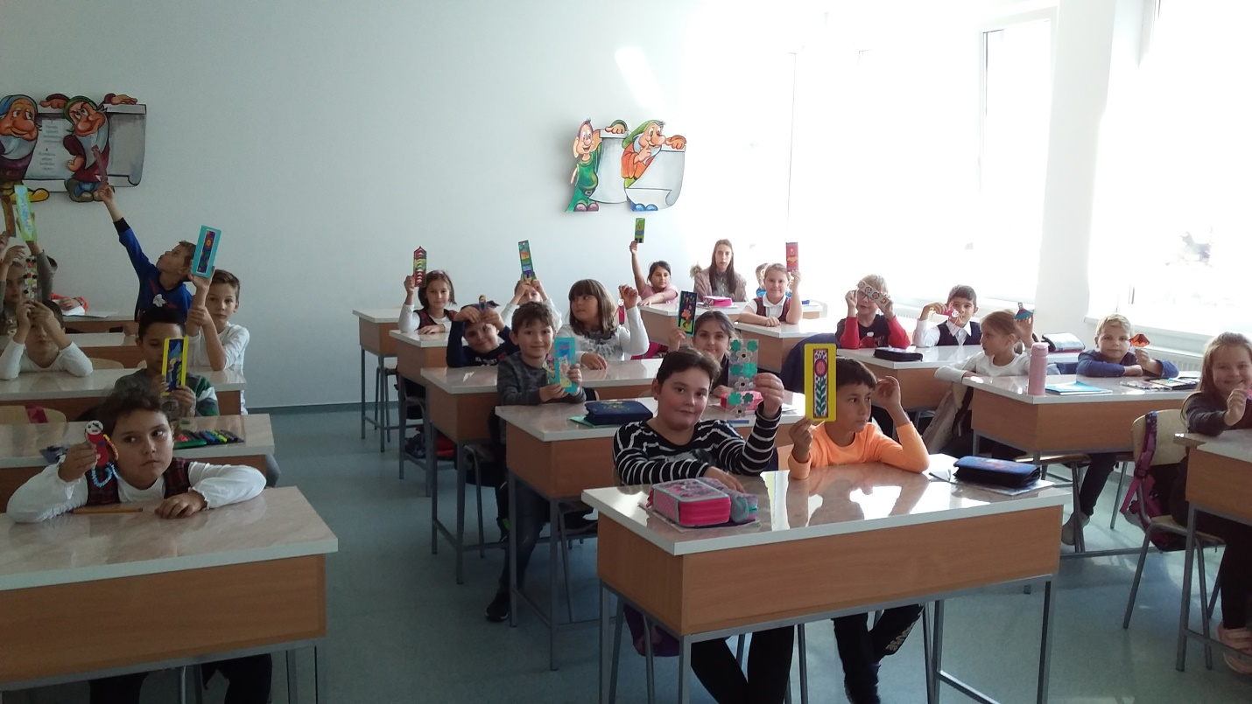

The students enthusiastically participated in various activities and displayed their artistic and literary skills.
- Guess, guess! – game to the preparatory classes and the first classes, we read riddles and colored characters from stories.
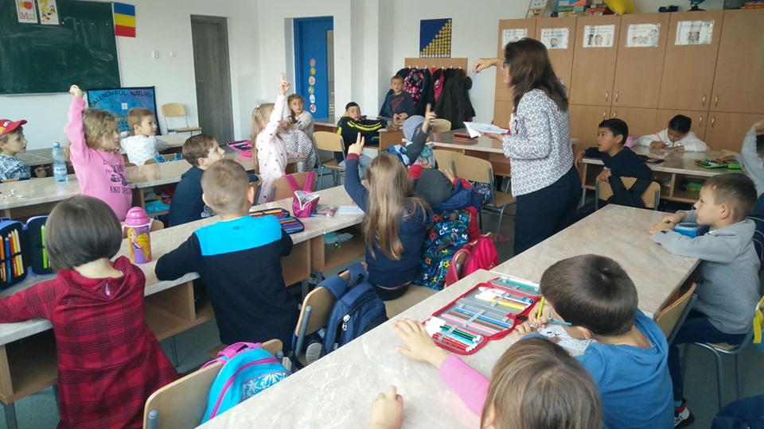
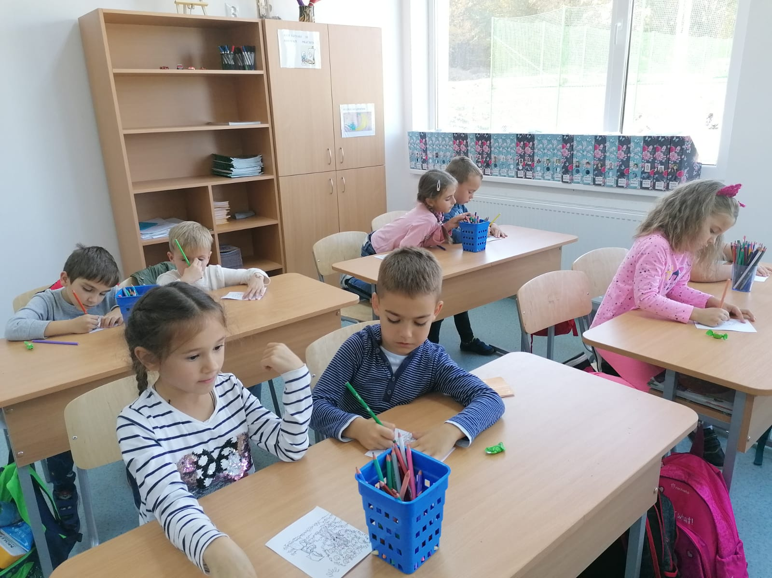

- Presenting a favorite book and awarding the best review.
Making a favorite book advertisement was made by describing and presenting it, so that developed the interest for reading .
- Creative writing! Articles for the school magazine!
That’s articles will be publicated in december in the school magazin “LECEAFARUL SCOLII”.
- Bingo books! contest - classes of V-VIII
The game was loved by the students.
I have chosen three writers from Romanian literature and until the sand leaked from the hourglass they placed their works in front of the writers and books.
Then from a ballot box they extracted the tickets with information about books written by foreign authors and they had to sit on the book described in the ticket.

- Imagine what the school library will look like in over 100 years!- contest of writing composition

The best rewiev
From the fortress of I to the fortress of You
Mersine Vigopoulou is the author of the book "From the fortress of I to the fortress of You". She was born in Thessaloniki and became known because of this book that is still circulating in America, England, Russia and Ukraine today.
In the city of I lived children and big people concerned only with them, their interests. The children did not play together for long because they were very upset: they all wanted to be first and be acclaimed.
The empress, the goddess Mândria, lived in a cloister palace, and all her subjects adored her and knew of her fear.
Until one day, Mâniosul, a small inhabitant goes to a city that has heard many. He thinks that if he gets there he will receive decorations, praises and will be appreciated by everyone. But in Thy city it was not so easy. If you had bad thoughts, more and more obstacles were coming your way, and good thoughts made their way smooth and short.
In the Fortress of You meet people totally different from those in his fortress, hospitable people, full of love, who cared for each other.
The angry man went through many spiritual states and left for the house completely changed, with the desire to bring his own into the Belt of You.
The experiences that the Handful has gone through make us all think, helps us get to know each other better and develop.
By Tania Chira-3rd class

The best creative writing!
The book as a portal
On a cold, cold winter day, Beatrice went to the library because she loved to read.
Looking through and browsing all the books on the shelves, he found a purple book that he wrote: The book as a portal. Being interested, she went to the library lady and said:
- I would like to borrow this book!
- A! Good choice! But know this book is special. Do you really want it?
Beatrice looks a little scared, why did the lady librarian say she was special, and suddenly became even more curious. Then he said:
- Of course! How not to!
- Would you like some useful tips on how to use it when I have to return it?
- Yes, thank you!
- The book has two parts, you will see. You better be careful! And to return the book we will see you in two weeks! Tell me how this book seemed to you!
- Of course! Goodbye!
Beatrice went home and started reading the book. When he opened it, he entered a portal where some teddy bears were asking for his help and if he would help them he would receive a reward. He had to rescue another teddy bear, who was about to fall into a waterfall. Beatrice saved him and said:
- Everyone makes mistakes!
A teddy bear said:
- Hooray! Successful rescue!
- The reward had been a book. Beatrice thanked them and left. Arriving home, he got up and went to bed happy, because tomorrow he will go to the library again!
By Cristina Popescu-4rd class

